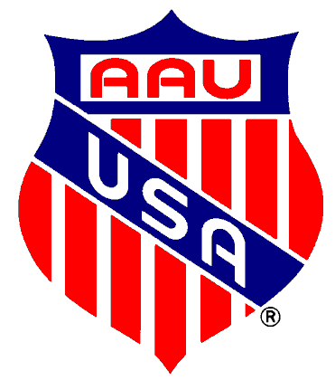 | AAU BOYS’  BASKETBALL NATIONAL  CHAMPIONSHIP  INTENT TO PARTICIPATE
HOST COPY
RETURN IMMEDIATELY

CHECK ONE: [ ] Our team will participate in this event

[ ] Our team will not participate in this event.

PLEASE COMPLETE THE INFORMATION BELOW AND FAX TODAY!
(410) 732 -8410 ATTN: Ben DuBose
AAU District:

Team Name: ______

City Representing: _____ ____________

Coach Name: ________

Address:

City: State: Zip:

Home Phone: ( ) Work: ( )

* EMAIL ADDRESS *__________________________Cell Phone: (______)_____________________________

Second Contact Name:

Address:

City: State: Zip:

Home Phone: ( ) Work: ( )

What National Tournament do you intend to participate in? Age / Division: ______________________________

This is not your team entry. This is only a notification of intent.

